 | 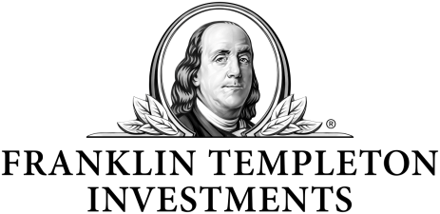 |  |  | 
UNIVERSITY OF MUMBAI’S
GARWARE INSTITUTE OF CAREER EDUCATION AND DEVELOPMENT
In collaboration with
AMERICAN INDIA FOUNDATION (AIF)
Supported by
FRANKLIN TEMPLETON ASSET MANAGEMENT (INDIA) PVT. LTD.
Offers

Market Aligned Skill Training ( MAST) Program

Special Drive for Economically Backward Students
Subsidized Certificate Courses for Skill Development

Course |  | Duration | Eligibility |  | Fees
STORE OPS ASSISTANT (RETAIL) |  | 6 months | 12th Passed (Any stream) |  | Rs. 2000/-
PAINT CHEMIST |  | 6 months | 12th Passed (Science) |  | Rs. 2000/-
SOFTWARE TESTING |  | 4 months | B. Sc IT/BCA/BCS or B.com |  | Rs. 2000/-
ADMISSION STARTING FROM 10TH NOVEMBER, 2016
COURSES COMMENCE ON 1ST DECEMBER, 2016

PLEASE CONTACT:
Tel.No: 022-26530258/59 | E-mail- garware@giced.mu.ac.in |Website:- www.giced.edu.in
Facebook Link: https://www.facebook.com/Garware-Institute-of-Career-Education-and-Development

